

**International School**

**CMU-CS 246 VIS**

**PROJECT PROPOSAL DOCUMENT**

**Date: 20 May, 2024**

**E-commerce techniques APPLICATION**

**Submitted by**

Thai Duy Tung

Nguyen Ngoc Duy

Tran Hong Phong

Le Thanh Tin

Nguyen Hoang Le Vy

**Approved by**

**Mentor:**

Name Signature Date Nguyen Trung Thuan ____________________________________ 18- Feb- 2024

**Proposal Review Panel Representative:**

Name Signature Date Nguyen Trung Thuan ____________________________________ 20- May- 2024

|  |  |
| --- | --- |
| **PROJECT INFORMATION** | |
| **Project**  **Acronym** | Group 6 |
| **Project Title** | Online Store Management System |
| **Start Date** | 18- Feb - 2024 |
| **End Date:** | 20 - May - 2024 |
| **Lead Institution** | International School, Duy Tan University |
| **Project Mentor** | M.Sc Thuan, Nguyen Trung |
| **Scrum Master** | Nguyen Ngoc Duy , [nguyenngocduyhehe@gmail.com](mailto:nguyenngocduyhehe@gmail.com) , 28211103078 |
| **Team Members** | Thai Duy Tung , thaiduytung09@gmail.com , 28212405393  Tran Hong Phong , tranhongphong147@gmail.com , 28211101246  Le Thanh Tin , tranthanhtin5103@gmail.com , 28210204063  Nguyen Hoang Le Vy , levy.23072004@gmail.com , 28219037632 |

|  |  |  |
| --- | --- | --- |
| **DOCUMENT INFORMATION** | | |
| **Document Title** | Project Proposal | |
| **Author(s)** | Team Group 6 | |
| **Role** | Billiards table access | |
| **Date** | 20 - May- 2024 | File name Doan_Bida_Club |

**URL https://github.com/team6cs246/team6_cs246VIS**

**Access** Project and CMU Program

1

**REVISION HISTORY**

|  |  |  |
| --- | --- | --- |
| **Version** | **Person(s)** | **Date Description Approval** |
| 1.1 | Nguyen Ngoc Duy | Update invoices, and spreadsheets , create the document , cosmit code back-end , create database , Scrum master |
| 1.2 | Thai Duy Tung | Query customer data , cosmit code back-end , Product Ower , UML diagram setup |
| 1.3 | Tran Hong Phong | Create a logout system , find image , development team |
| 1.4 | Le Thanh Tin | Create UI dashboard , Set date and time , development team |
| 1.5 | Nguyen Hoang Le Vy | Create UI Login , Logout , development team |

2

**1. Introduction 4**

**2. Problem Definition 5**

2.1. Business needs 5

2.2. Business values 5

2.3. Business goal 5

2.4. Project Solution 5

**3. Current Status of Art 6**

**4. Engineering Approach 7**

**4.1. System Context Diagram 7**

**4.2. System Context Description 7**

**4.3. Constraints 8**

4.3.1. Technical constraints 8

4.3.2. Environments constraint 9

4.3.3. Other Constraints 9

**5. Tasks and Deliverables 9**

5.1. Task and scope 9

5.2. Deliverables 10

**6. Project Management 10**

6.1 Cost/Budget for Project 10

6.2. Tentative Schedule 11

6.2.1. Scrum process 11

6.2.3. Master Plan 11

**7 . Project Constraints 12**

**8. Conclusion 16**

**9. References 16**

**10. Attachment: DESCRIPTION OF PRODUCT REQUIREMENTS FORM 17**

3

**1. Introduction**

The application was developed to address the practical need for assistance in renting products from an e-commerce platform for individuals with busy work schedules who require convenient shopping solutions after long and stressful workdays. It is designed for an organization facilitating user shopping, which establishes partnerships with shipping services. The system integrates with product catalogs from various branches, allowing users to browse and select products for purchase. Users can place orders, specify delivery times, and complete payments using direct or electronic wallets.

Key features of the application include:

Customer registration and profile setup, including defining default delivery preferences.

Product selection, order placement, and delivery time scheduling.

Order management, including queuing, sorting, and scheduling based on predefined policies.

Coordination with shipping services for order fulfillment, including purchasing and delivery.

Transaction recording to ensure order completion.

Support for dispatchers to reassign orders to alternative shippers if issues arise during delivery.

Data analysis capabilities for making informed suggestions based on collected data sources such as Excel or web scraping.

Automation of system tasks to enable seamless operation without constant user intervention.

Built upon the foundation of a mobile application utilizing APIs and services, the application streamlines the shopping experience for consumers, providing convenient access to products and efficient delivery services.

4

**2. Problem Definition**

**2.1. Business needs**

* Consumers want a tool that will facilitate their easy, quick, and efficient online buying demands. They demand priority assistance when they need it and assured downtime in between work sessions.

- Apps that can gather data from customers in need of assistance and offer services are essential for vendors. Their goal is to broaden their range of endeavors.

**2.2. Business values**

* Users are able to communicate clearly and act promptly. Furthermore, services can minimize the chance of time and effort loss and can arrange help in the quickest manner, all while facilitating user access to it. Users can then unwind after work with its assistance.

**2.3. Business goal**

* Develop an app that can assist users efficiently and promptly after a long day at work, as well as promptly reply to user demands. Participate in the creation of regional services, etc.

**2.4. Project Solution**

* Making a simple application facilitates users' ability to locate assistance when needed.

**End Users can:**

● Personal information management.

● View product suggestions

● Order product

● Buy products

● View cart

● View history

● Payment

**SysAdmin can:**

5

● Manage shipper accounts

● Show dashboard

● Add product

* Product Management
* View order
* Product revenue

**User can:**

● Find Product

● Add to cart

● See the name, phone number, and address of the person placing the order

**3. Current Status of Art**

Currently, there are a few applications that offer market shopping services, but they lack comprehensive functionality and optimal user support. These existing applications require users to provide their location and an extensive amount of personal information, making the ordering process time-consuming and cumbersome.

Our application is designed to address these shortcomings and meet user needs more effectively. Users can quickly and efficiently select the services they need, ensuring they can enjoy their rest time after work. Additionally, the application offers dedicated customer support and allows users to place orders instantly.

**4. Engineering Approach**

**4.1. System Context Diagram**

6

*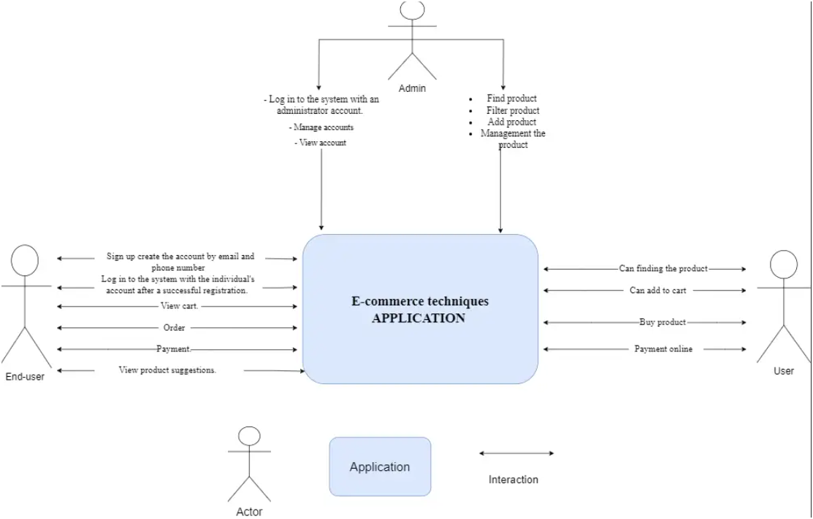***Figure 1: System Context Diagram**

**4.2. System Context Description**

**4.2.1 End User**

- Sign up create the account by email and phone number

- Log in to the system with the individual's account after a successful

registration.

- View cart.

- Order

- Payment.

- View product suggestions.

- See delivery time.

- Order product.

**4.2.2 Admin**

- Log in to the system with an administrator account.

- Manage accounts

- View account

Product

* find product
* filter product
* add product
* management the product

**4.3. User**

* Can finding the product
* Can add to cart
* Buy product
* Payment online

**4.3.1. Technical constraints**

Language: JavaScript.

Develop tools: Visual Studio Code and Netbeans

**4.3.2. Environments constraint**

- App environment: Android,IOS.

**4.3.3. Other Constraints**

- Resource: 5 people.

- Budget: Limited.

- Time: The project must be completed within 3,5 months.

- These features are not available in the first version of products. 12

**5. Tasks and Deliverables**

**5.1. Task and scope**

- Gathering requirements, the professional user.

- Learning the technologies need to solve the problem.

- Planning project implementation.

- Build the system from the user side.

- Testing.

- Releases.

9

**5.2. Deliverables**

- Proposal Document.

- Project Plan Document.

- Product Backlog

- Sprint Backlog Document.

- Architecture Design Document.

- Database Design Document.

- Test Case and Test Report Document.

- Test Plan Document.

- Meeting Document.

- Source code.

**6. Project Management**

**6.1 Cost/Budget for Project**

|  |  |
| --- | --- |
| **Category** | **Detailed Description** |
| **Start date** | Feb 21 , 2024 The start date of the project. |
| **End date** | May 10, 2024 The end date of the project. |
| **Duration (1)** | 78 Total days of project. |
| **Working time (2)** | 4 hours/day In one day and for one member. |
| **Total effort (3) = (1)**  **\* (2) * 4** | 1872 hrs. For four team members and the entire project. |

**Labor cost (4) = (3) * 2**

1223 $ For four team members and the entire project. ($2.0/ member)

10

**6.2. Tentative Schedule**

**6.2.1. Scrum process**

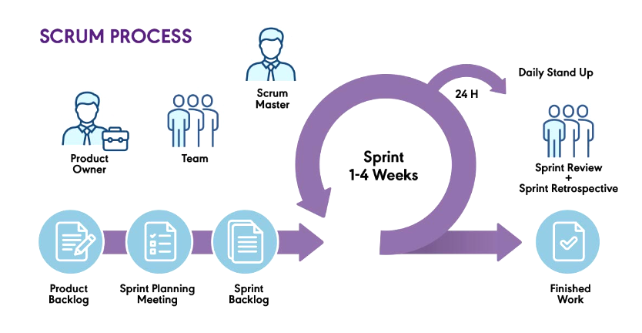

**6.2.3. Master Plan**

|  |  |  |  |  |
| --- | --- | --- | --- | --- |
| **NO** | **Task Name** | **Duration (Day(s))** | **Start Finish** | **Effort work (hrs.)** |
| **1** | **Initial** | **6** | **21/2/2024 27/2/2024** | **43** |
| 1.1 | Create Proposal  Document | 2 | 21/2/2024 23/2/2024 | 17 |
| 1.2 | Meeting | 1 | 24/2/2024 24/2/2024 | 16 |
| 1.3 | Discuss about project idea | 2 | 25/2/2024 26/2/2024 | 10 |
| 1.4  **2** | Update Proposal  Document  **Create Document** | 1  **7** | 27/2/2024 27/2/2024 **28/2/2024 14/3/2024** | 8  **117** |
| 2.1 | Create Project Plan | 2 | 28/3/2024 4/3/2024 | 40 |

11

|  |  |  |  |  |
| --- | --- | --- | --- | --- |
| 2.2 | Create User Stories | 3 | 5/3/2024 8/3/2024 | 40 |
| 2.3 | Create Product  Backlog | 2 | 9/3/2024 14/3/2024 | 37 |
| **3** | **Development** | **51** | **15/3/2024 18/5/2024** | **170** |
| 3.1 | Sprint 1 | 20 | 15/3/2024 13/4/2024 | 65 |
| 3.2 | Sprint 2 | 18 | 14/4/2024 1/5/2024 | 48 |
| 3.2 | Sprint 3 | 13 | 2/5/2024 19/5/2024 | 57 |
| **4** | **Project Meeting** | **5** | **19/5/2024 19/5/2024** | **8** |
| **5** | **Final Release** | **1** | **20/5/2024 20/5/2024** | **5** |
| **Total** | **70** | **21/2/2024 20/5/2024** | **343** |

**7 . Project Constraints**

|  |  |
| --- | --- |
| **Constraints** | **Description** |
| **Economic** | Account for environmental factors (temperature, humidity, vibration, electromagnetic interference, shock) and the impact of design on the environment. Consider recycling and the use of recycled materials. |

12

|  |  |
| --- | --- |
| **Environmental** | Address intellectual property, reverse engineering, privacy, security, and the conflict between cost and safety. Create an application that meets growing user needs, secures information, and allows easy interaction |
| **Ethical** | Ensure ethical integrity, user privacy, and secure interactions. Efficiently manage shipper assignments to avoid order delays and simplify the shopping list to exclude hard-to-find items. |
| **Public health, safety, and**  **welfare** | Ensure hygiene and safety, especially during pandemics. Shippers should follow hygiene protocols, such as wearing masks, when buying and delivering goods. |

13

|  |  |
| --- | --- |
| **Social and**  **Global** | Consider benefits, risks, user acceptance, and socially responsible engineering. |
| **Cultural** | Address accessibility differences between urban and rural areas and the impact of cultural characteristics on design. |

14

|  |  |
| --- | --- |
| **Sustainability** | * When developing our product, it must be designed for quick, long-term use to meet urgent and essential user needs. The application should be reliable and safe for users. * Effective operation requires understanding the system thoroughly and quickly identifying and fixing errors to minimize user impact. * Prompt error resolution is crucial when the system crashes. * Gaining and maintaining user trust is essential for the application's long-term sustainability and effectiveness. * The application's supporting infrastructure must be safe and reliable, ensuring long-term usability. * Investors must continually update the product and maintain credibility to build user trust. |

15

**8. Conclusion**

- We will build an application that can provide user support services in the field of shopping, ensuring maximum time savings for users in case they do not have time to go to the E-commerce techniquesor are busy with work. work in everyday life. This application can help reduce the time for human life.

- This application will be a useful system as it will bring needed service to everyone. It will support anytime, anywhere when users need it. The application will help save time and effort, in case you do not have time to go to the E-commerce techniquesbecause work is too busy. Therefore, the E-commerce techniquesshopping application will be born and actively work to improve people's lives and save people's time.

**9. References**

|  |  |  |
| --- | --- | --- |
| **No.** | **References** | **Document Information** |
| **1** | **Scrum**  **Model** | https://en.wikipedia.org/wiki/Scrum_(software_developmen t) |
| https://www.atlassian.com/agile/scrum |
| https://www.digite.com/agile/scrum-methodology/ |
| https://www.techtarget.com/searchsoftwarequality/definition /Scrum |

16

|  |  |  |
| --- | --- | --- |
|  |  | https://learn.microsoft.com/en-us/azure/devops/boards/sprin ts/best-practices-scrum?view=azure-devops |
| https://www.scrum.org/resources/scrum-guide |
| **2** | **Technical** | https://reactnative.dev/docs/getting-started |
|  |  | https://www.w3schools.com/react/react_lifecycle.asp |
|  |  | https://www.mongodb.com/docs/ |
| **3** | **Software**  **Engineeng**  **Standards** | https://www.nws.noaa.gov/oh/hrl/developers_docs/General_ Software_Standards.pdf  https://standards.ieee.org/standard/12208-2017.html |

https://sw-eng.larc.nasa.gov/

**10. Attachment: DESCRIPTION OF PRODUCT REQUIREMENTS FORM**